
Who are we?
Just another PCB company? Ohhh NO! NO! NO!
We make PCBS and PCBA for a reason, and that is just
The BEGINNING of our Mission.
We make the stuff that keeps the world connected....without printed circuit boards (PCBs) the world would eventually stop. We depend too much on technology, to ever live without it again.
Diversity and unity of people and companies around the world, have to unite and contribute to the continuation of technology and connectivity amongst each other.
SA ELECTRONICS INC. is ready for the future, while protecting our planet AND the future generations. Our future vision for the Tomorrow People is to offer them a college for electricians FREE of charge. A place where anyone with passion can attend and bring our world into a better tomorrow, with a sweeter perspective.
We have big goals and even bigger dreams, but we need everyone to become part of it. Talk about us, get the word out about SA ELECTRONICS so we can get the ball rolling even faster. Visit our site, (WWW.SAELECTRONICS.ORG) leave emails, send me suggestions, we are in this together, even if we are all working for a different company, we all live on the same planet with the same environmental problems.
Let's start with the right foot and dream a bigger dream together. I know all of you know how to be a great leader for your company, but let's become a great leader for our planet. Let's keep the world running....into a better tomorrow.
In the words of Jason Jennings, let's all "do well by doing good".
I am looking forward to hearing from you soon. Have an absolutely outstanding day!
PCB@SAELECTRONICS.ORG WWW.SAELECTRONICS.ORG

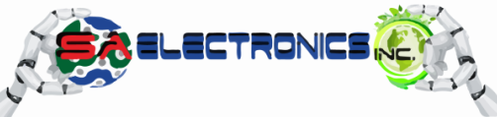
Anita Serbanescu, President

Building WHILE Protecting the Future!!​
708-571-5519

